RabbitMQ添加通道

1：RabbitNQ启动之后，网页登录：

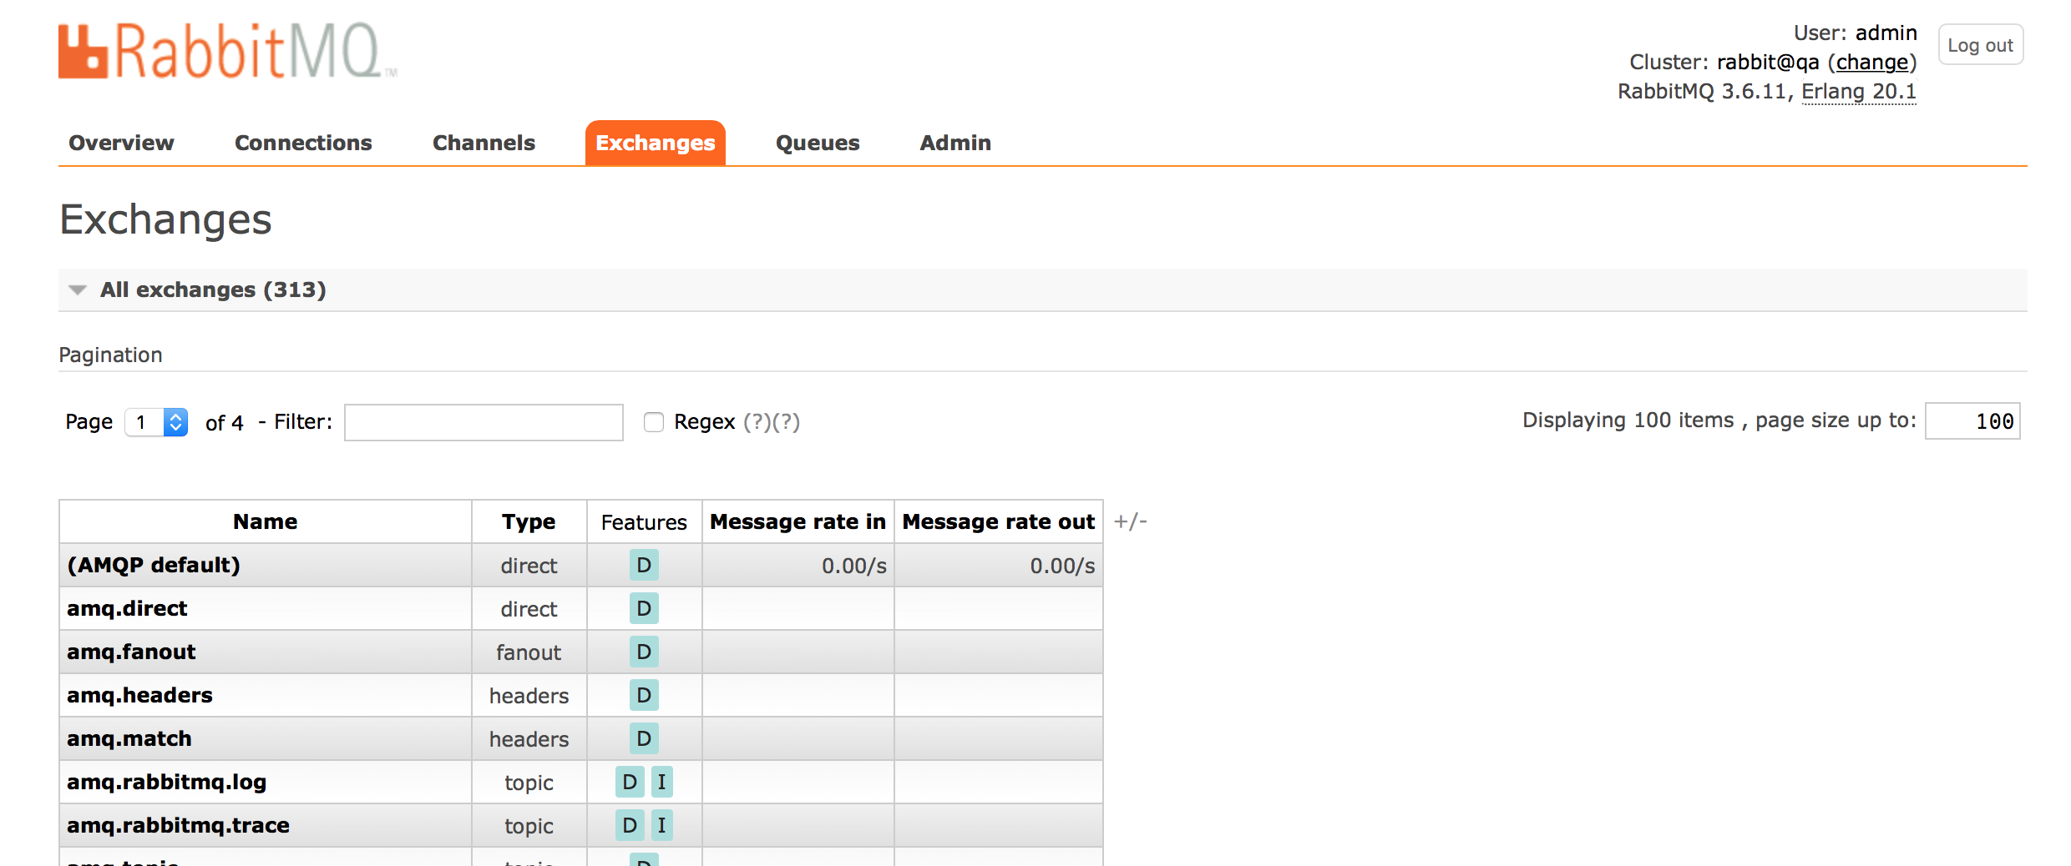

2：选择exchanges



type选择 fanout



点击创建即可 一个币对有13个通道需要创建

| Name | Type | Features | Message rate in | Message rate out | +/- |
| --- | --- | --- | --- | --- | --- |
| [**market_bchbtc_depth_step0**](http://39.106.139.147:15673/#/exchanges/%2F/market_bchbtc_depth_step0) | fanout | D | 0.00/s | 0.00/s |  |
| [**market_bchbtc_depth_step1**](http://39.106.139.147:15673/#/exchanges/%2F/market_bchbtc_depth_step1) | fanout | D | 0.00/s | 0.00/s |  |
| [**market_bchbtc_depth_step2**](http://39.106.139.147:15673/#/exchanges/%2F/market_bchbtc_depth_step2) | fanout | D | 0.00/s | 0.00/s |  |
| [**market_bchbtc_kline_15min**](http://39.106.139.147:15673/#/exchanges/%2F/market_bchbtc_kline_15min) | fanout | D | 0.00/s | 0.00/s |  |
| [**market_bchbtc_kline_1day**](http://39.106.139.147:15673/#/exchanges/%2F/market_bchbtc_kline_1day) | fanout | D | 0.00/s | 0.00/s |  |
| [**market_bchbtc_kline_1min**](http://39.106.139.147:15673/#/exchanges/%2F/market_bchbtc_kline_1min) | fanout | D | 0.00/s | 0.00/s |  |
| [**market_bchbtc_kline_1month**](http://39.106.139.147:15673/#/exchanges/%2F/market_bchbtc_kline_1month) | fanout | D | 0.00/s | 0.00/s |  |
| [**market_bchbtc_kline_1week**](http://39.106.139.147:15673/#/exchanges/%2F/market_bchbtc_kline_1week) | fanout | D | 0.00/s | 0.00/s |  |
| [**market_bchbtc_kline_30min**](http://39.106.139.147:15673/#/exchanges/%2F/market_bchbtc_kline_30min) | fanout | D | 0.00/s | 0.00/s |  |
| [**market_bchbtc_kline_5min**](http://39.106.139.147:15673/#/exchanges/%2F/market_bchbtc_kline_5min) | fanout | D | 0.00/s | 0.00/s |  |
| [**market_bchbtc_kline_60min**](http://39.106.139.147:15673/#/exchanges/%2F/market_bchbtc_kline_60min) | fanout | D | 0.00/s | 0.00/s |  |
| [**market_bchbtc_ticker**](http://39.106.139.147:15673/#/exchanges/%2F/market_bchbtc_ticker) | fanout | D | 0.00/s | 0.00/s |  |
| [**market_bchbtc_trade_ticker**](http://39.106.139.147:15673/#/exchanges/%2F/market_bchbtc_trade_ticker) | fanout | D | 0.00/s | 0.00/s |  |